Overall reports:
Below screenshot is of consolidated one, every run is getting captured in the form of report and it gives how many times we have executed it.
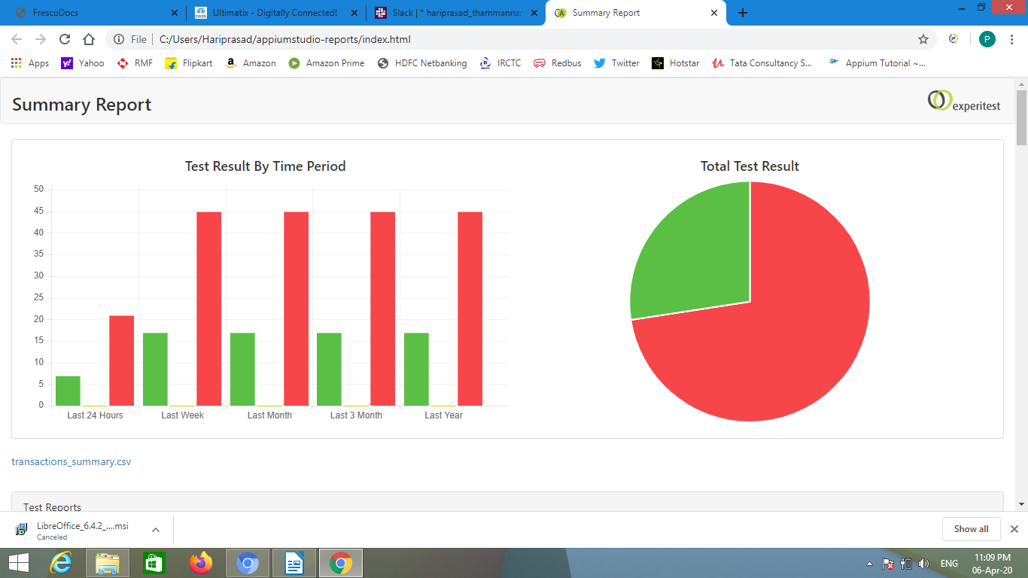

Below two screenshots has the latest test steps execution summary along with the device details.
